Substance: A |  | Molecular formula: C₃H₆O_{3 (TASK SOLUTIONS)}
INFORMATION GAINED FROM CHEMICAL TESTS AND OTHER OBSERVATIONS
Test # | Description of test / observation |  |  | Inferences
1 | Add 2 drops of CaCO₃ (s) => N.V.R |  |  | Does not react with a carbonate – not an acid
2 | Add 3 drops of dilute KMnO₃(aq) => N.V.R |  |  | Does not oxidise hence not a primary or secondary alcohol
3 | Add 2 drops of universal indicator => green colour |  |  | Neutral solution. No presence of H⁺ or OH⁻ ions.
4 | Add 2 mL of glacial acid and 2 drops of concentrated H₂SO₄ => N.V.R |  |  | No esterification taking place. Therefore anything but an alcohol.
5 | Add 2 mL to 10 mL of water => fully soluble in water – nail polish remover smell |  |  | Polar molecule
Name the functional group present |  |  | Ketone (propanone – acetone)
Drawing and name of a possible structure that matches all data:

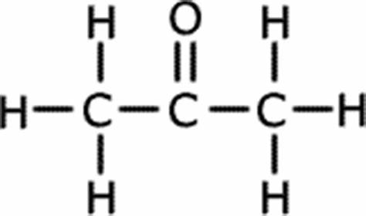 propanone

 |  |  |  | Criteria |  | Marks
 |  |  |  | Clarity in logic |  | ___ / 2
 |  |  |  | Correct functional group |  | ___ / 1
 |  |  |  | Structure |  | ___ / 1
 |  |  |  | Name |  | ___ / 1
Substance: B |  | Molecular formula: C₃H₈O₃
INFORMATION GAINED FROM CHEMICAL TESTS AND OTHER OBSERVATIONS
Test # | Description of test / observation |  |  |  | Inferences
1 | Add 2 drops of CaCO₃ (s) => N.V.R |  |  |  | Does not react with a carbonate – not an acid
2 | Add 3 drops of dilute KMnO₃(aq) => discolours the purple solution to pale pink |  |  |  | Does oxidise hence is either a primary or secondary alcohol
3 | Add 2 drops of universal indicator => green colour |  |  |  | Neutral solution. No presence of H⁺ or OH⁻ ions.
4 | Add 2 mL of glacial acid and 2 drops of concentrated H₂SO₄ => fruity smell |  |  |  | Esterification taking place. Therefore an alcohol present.
5 | Add 2 mL to 10 mL of water => fully soluble in water (easily) |  |  |  | Polar molecule – hydrogen bonding (-OH group with an alcohol)
Name the functional group present |  |  | Alcohol (propan-1-ol or propan-2-ol)
Drawing and name of a possible structure that matches all data:

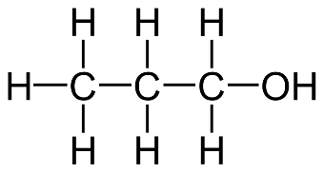 propan-1-ol 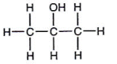propan-2-ol

 |  |  |  | Criteria |  | Marks
 |  |  |  | Clarity in logic |  | ___ / 2
 |  |  |  | Correct functional group |  | ___ / 1
 |  |  |  | Structure |  | ___ / 1
 |  |  |  | Name |  | ___ / 1
Substance: C |  | Molecular formula: C₈H₈O₃
INFORMATION GAINED FROM CHEMICAL TESTS AND OTHER OBSERVATIONS
Test # | Description of test / observation |  |  |  | Inferences
1 | Add 2 drops of CaCO₃ (s) => N.V.R |  |  |  | Does not react with a carbonate – not an acid
2 | Add 3 drops of dilute KMnO₃(aq) => N.V.R |  |  |  | Does not oxidise hence not a primary or secondary alcohol
3 | Add 2 drops of universal indicator => slight purple colour |  |  |  | Basic solution - slight. Presence of OH⁻ ions.
4 | Add 2 mL of glacial acid and 2 drops of concentrated H₂SO₄ => N.V.R |  |  |  | No esterification taking place. Therefore anything but an alcohol.
5 | Add 2 mL to 10 mL of water => limited solubility in water |  |  |  | Low polarity molecule due to shape or complexity of the molecule – hence a triple bonded cyclic compound
Name the functional group present |  |  | Ester and alcohol (methyl salicylate)
Drawing and name of a possible structure that matches all data:

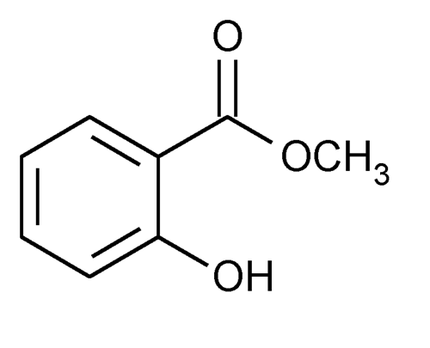 methyl salicylate - similar with identical functional groups

 |  |  |  | Criteria |  | Marks
 |  |  |  | Clarity in logic |  | ___ / 1
 |  |  |  | Correct functional group |  | ___ / 1
 |  |  |  | Structure |  | ___ / 1
 |  |  |  | Name |  | ___ / 1
Substance: D |  | Molecular formula: C₄H₈O₂
INFORMATION GAINED FROM CHEMICAL TESTS AND OTHER OBSERVATIONS
Test # | Description of test / observation |  |  |  | Inferences
1 | Add 2 drops of CaCO₃ (s) => colourless bubbles |  |  |  | Does react with a carbonate – is an acid
2 | Add 3 drops of dilute KMnO₃(aq) => N.V.R |  |  |  | Does not oxidise hence not a primary or secondary alcohol
3 | Add 2 drops of universal indicator => slight orange colour |  |  |  | Acidic solution - slight. Presence of H⁺ ions.
4 | Add 2 mL of glacial acid and 2 drops of concentrated H₂SO₄ => N.V.R |  |  |  | No esterification taking place. Therefore anything but an alcohol.
5 | Add 2 mL to 10 mL of water => fully soluble in water (easily) |  |  |  | Polar molecule – hydrogen bonding (-OH group with an alcohol)
Name the functional group present |  |  | Acid (butanoic acid)
Drawing and name of a possible structure that matches all data:
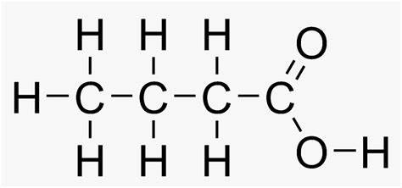 butanoic acid

Criteria | Marks
Clarity in logic | ___ / 2
Correct functional group | ___ / 1
Structure | ___ / 1
Name | ___ / 1

